Project Report on

**Analysis of Photocatalytic degradation using Artificial Neural Network**

to be submitted in Partial Fulfillment of

the Requirements for the Award

of the Degree of

**Bachelor of Technology**

In

**Chemical Engineering**

By

**ANSHIKA (2017BCHE016)**

**SANDEEP SINGH TOMAR (2017BCHE029)**

**ARPIT SHUKLA (2017BCHE062)**

**Under the Guidance of: -**

**TANVEER RASOOL**

**(ASSISTANT PROFESSOR)**

**Department of Chemical Engineering**



**DEPARTMENT OF CHEMICAL ENGINEERING**

**NATIONAL INSTITUTE OF TECHNOLOGY SRINAGAR**

**JUNE 2021**



**DEPARTMENT OF CHEMICAL ENGINEERING,**

**NATIONAL INSTITUTE OF TECHNOLOGY, SRINAGAR KASHMIR-190006 (INDIA)**

**JUNE-2021**

**CANDIDATE’S DECLARATION**

We hereby certify that the work which is being presented in this report entitled “**Analysis of Photocatalytic degradation using Artificial Neural Network”** in partial fulfillment of the requirement for the award of the degree of Bachelor of Technology submitted in the **Department of Chemical Engineering, National Institute of Technology, Srinagar, Kashmir** is an authentic record of our work carried out during the period from December 2020 to June 2021 under the supervision of **Tanveer Rasool** , Department of Chemical Engineering, National Institute of Technology, Srinagar, Kashmir.

We also affirm that the matter presented in the report has not been submitted by us for the award of any degree of this or any other University/Institute.

**(Anshika) (Sandeep Singh Tomar) (Arpit Shukla)**



**DEPARTMENT OF CHEMICAL ENGINEERING,**

**NATIONAL INSTITUTE OF TECHNOLOGY, SRINAGAR KASHMIR-190006 (INDIA)**

**JUNE-2021**

This is to certify that the project report entitled, “**Analysis of Photocatalytic degradation using Artificial Neural Network”** has been prepared and submitted by Ms. Anshika(2017BCHE016), Mr. Sandeep Singh Tomar(2017BCHE029), Mr. Arpit Shukla(2017BCHE062), under my guidance and supervision. It is the final report of the work carried out by the above mentioned students and is being submitted by them in partial fulfillment of the award of the degree of Bachelor of Technology (B. Tech) in Chemical Engineering by National Institute of Technology, Srinagar, Kashmir-190006 (India).

(Project Guide)

Tanveer Rasool

Assistant Professor

Department of Chemical Engineering

National Institute of Technology, Srinagar

**Signature of Project Guide Signature of External Examiner Signature of H.O.D.**

**ACKNOWLEDGEMENT**

At this opportunity, we would like to extend our gratitude to **Tanveer Rasool**, Asst. Professor, Department of Chemical Engineering, National Institute of Technology Srinagar, who inspired us to work on the project “**Analysis of Photocatalytic degradation using Artificial Neural Network”.** His calm demeanor and words of encouragement motivated us to keep going, even when being busy with his diurnal duties. He had made all the equipment and chemicals necessary to our work conveniently available. We sincerely thank him for his help, guidance and encouragement with the utmost affection and appreciation. Without Tanveer Rasool, the successful completion of this project wouldn’t have been possible.

We wish to express our thanks to **Dr. M.A.Rather**, **Head of Chemical Engineering Department** who was always ready with pertinent advice and encouragement when needed.

We are also grateful for the support of the entire Chemical Engineering Department for helping us make this project extensive and complete.

**ANSHIKA**

**(2017BCHE016)**

**SANDEEP SINGH TOMAR**

**(2017BCHE029)**

**ARPIT SHUKLA**

**(2017BCHE062)**

**ABSTRACT**

The epidemic growth of the pharmaceuticals industries over the years in order to meet the human demands had exerted substantial pressure on the global environment, particularly the water pollution crisis. Herein, the photocatalytic degradation of phenol was investigated via commercial TiO2 nanoparticles. The Artificial Neural Network (ANN) suitable modelling and optimized condition of the TiO2 nanoparticles in yielding a profound rate of phenol removal. The parameters of investigation involved pH, phenol concentration, catalyst doses and degradation time. The designed system fits well with the Pseudo-First-Order and the Langmuir isotherm model with R=0.986. On the other hand, the ANN study revealed that the predicted model was perfectly fitted with the experimental data giving the highest value of R. The data was taken from different research papers and a model was trained on that data set and predictions and testing were made on the same data to cross check the validity of the model.

Keywords:

TiO2

Photocatalytic degradation

Artificial neural network

Phenol

Degradation mechanism

**CONTENTS**

**TOPIC** **PAGE NUMBER**

CANDIDATE’S DECLARATION II

CERTIFICATE III

ACKNOWLEDGMENTS IV

ABSTRACT V

CONTENTS VI

LIST OF FIGURES VII

LIST OF TABLES VIII

1. INTRODUCTION 1-3

1.1. Effects of Phenol Contamination 2

1.2. Phenol Treatment Methods 3

2. LITERATURE REVIEW 4-19

3. MOTIVATION AND OBJECTIVES 20-21

4. MATERIALS AND METHODS 22-23

4.1. Chemical Required 22

4.2. Photocatalytic Degradation Studies 22

4.3. Artificial Neural Network 23-24

4.4. Model Development 25

5. RESULTS AND DISCUSSION 26-31

6. CONCLUSIONS & FUTUREWORK 32-33

7. FUTURE RECOMMENDATION 34

8. REFERENCES 35-36

**LIST OF FIGURES**

|  |  |
| --- | --- |
| **Figure Details** | **Page Number** |
| Figure 1: Photocatalytic degradation of phenol using TiO2 | 3 |
| Figure 2: ANN Architecture | 24 |
| Figure 3: Neural Network Architecture for photodegradation of phenol using TiO2 | 25 |
| Figure 4: Validation and training data plot | 29 |
| Figure 5: Performance curve of ANN | 31 |
| Figure 6: Figure showing R values for different stages of Training. | 33 |

**LIST OF TABLES**

|  |  |
| --- | --- |
| **Table Details** | **Page Number** |
| Table 1: Different pollutants and catalyst used to remove them | 8-19 |
| Table 2: Model parameters | 26 |
| Table 3: RMSE values for training data set corresponding to no. of neurons in hidden layer | 27-28 |
| Table 4: Actual/Experimental vs Predicted Values by ANN | 29-30 |

**1. INTRODUCTION**

Water is an essential element for all people living on the earth, and it is considered the most precious resource of human civilization. Reliable access to clean, clean and cheap water is an important goal and remains a major global challenge in the 21st century. In recent years, with the intensification of industrial and agricultural activities, the continuous discharge of toxic organic pollutants into water bodies and the open air without any treatment, large amounts of heavy metals and other substances, is a heavy responsibility. , Dyestuffs, Surfactants. Water-soluble organic pollutants, medicines, pesticides, personal care products, etc. pollute water resources. In particular, water-soluble organic pollutants, especially phenolic compounds, have an annual global production of about 3 million tons, which is an emerging pollutant (ECs). According to Malaysia’s Department of Environment (DOE), approximately 1000–6700mg/L of phenolic com- pounds are entered into the Malaysian environment from different industrial sectors especially palm oil, petroleum refinery, textile, Pharmaceutical, pulp and paper. Phenols are presentative phenolic compound and found to be the most important organic compounds due to their widespread use in many industrial processes. It is quite dangerous and noxious contaminant even present in small concentration.

The development of automatic wastewater treatment plants is also important to avoid hazards. ct pollutants, reducing the operating costs of sewage treatment plants. This requires a computer model. Artificial neural communities are effectively used to expand the version of sewage treatment plants with toxic reactive dyes.Reactive dyes are often used in textile dyeing, paper printing and leather dyeing. Wastewater from these industries contains a large amount of unused colors. Reactive dyes are toxic to all humans and aquatic organisms, even at low concentrations. They are clearly visible in wastewater. Industrial wastewater needs to be adequately treated before being discharged into the environment. Traditional biological processes are not very effective for the treatment of reactive dyes because they are not biodegradable. Some researchers have further explored membrane processes such as nanofiltration, but the membrane process requires high pressure, which will also increase the overall cost of treatment . Due to their short length and excessive solubility, the flocculation and precipitation process is no longer suitable for dye removal. The adsorption process is a suitable and inexpensive process. Despite the many advantages, the removal of used adsorbent is the main disadvantage of the adsorption process. The recovery and

reuse of used adsorbent is the solution to the adsorption process. Advanced oxidation process (TiO2/UV) is a very effective adsorbent regeneration technology due to its low cost, high chemical stability of the catalyst and the use of sunlight as a radiation source. The TiO2 particles adsorb dye molecules and oxidize them under ultraviolet radiation. There is no problem with the removal of sediment, and the final product is relatively less toxic compared with these dyes. In this study, TiO2 was used as the photocatalyst. The test was carried out at different pH values, different doses of TiO2, and different initial dye concentrations. Based on these experimental data, an artificial neural network model was developed. This model can be used to initially estimate the efficiency of adsorption and catalyst loading. For each pH value and each dye concentration. The model first uses some experimental data for training, and then compares with some other experimental data to validate the model.

**1.1 Effects of Phenol Contamination**

Phenol is an industrial process waste that enters aquatic ecosystems and has adverse effects on local biota, including algae, protozoa, invertebrates and vertebrates. Heavy exposure to phenol can be fatal to humans; babies are very sensitive to phenol. The biggest danger of phenol is that it can quickly penetrate the skin and cause severe burns. Toxic or even lethal amounts of phenol can be absorbed through a relatively small area of ​​the skin. Due to its local anesthetic properties, skin burns can be painless.

Phenol and its derivatives are used in many petrochemical and oil refining industries, as well as the chemical and pharmaceutical industries. Since the toxicity of phenolic compounds is a serious problem, their concentration is inhibited or even suppressed.Eliminate microorganisms in biological sewage treatment plants. Therefore, the presence of phenols greatly reduces the biodegradation of other ingredients.

**1.2 Phenol Treatment Methods**

There are many ways to remove phenolic compounds, and traditional destructive technologies such as biological treatment and adsorption in the activated carbon treatment process are effective in water purification. But they only transport pollutants from one environment to another. They are also slow processes, and the high concentration of organic pollutants in the past decade has caused some difficulties. In the past ten years, there has been a lot of interest in promising technologies.Based on the use of advanced oxidation processes (AOP) to oxidize hazardous and difficult-to-handle organic compounds. AOP is based on the formation of hydroxyl radicals, which are the main cause of oxidation of many waterborne organic pollutants. This species is a strong oxidant; however, due to its high reactivity, it is unstable and must be continuously produced in situ through chemical or photochemical reactions. Various methods of generating hydroxyl radicals include ozone using ultraviolet rays, hydrogen peroxide using ultraviolet rays, and photocatalysis using semiconductors combined with ultraviolet radiation and molecular oxygen. Some of these processes, such as ozonation, are more expensive than using UV catalysts. The use of titanium dioxide as a photocatalyst has received great attention due to its effectiveness. It is non-toxic, highly active, photochemically inert and low in price.

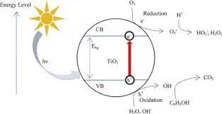

Figure 1: Photocatalytic degradation of phenol using TiO2

**2. LITERATURE REVIEW**

This chapter reviews previous work and studies on the photocatalytic degradation of phenol by TiO2 nanoparticles. The aim was to provide information that would provide the context within which the project on degradation of phenol by TiO2 could be Undertaken more comprehensively. The Artificial Neural Network (ANN) was used for computing the suitable modelling and optimized condition of the TiO2 nanoparticles in yielding a profound rate of phenol removal. The parameters of investigation involved pH, phenol concentration, catalyst doses and degradation time. This work provides an insight into statistical modelling and optimization which could provide exposure for developing an optimized nanomaterial towards the removal of hazardous pollutants. This chapter deals with photocatalytic degradation of phenol by mixing the appropriate quantity of TNPs in 300 mL of phenol solution with known concentration. In the entire study, ANN was successfully applied to predict the degradation (%) of phenol.

**Zulfiqar et al. (2019)** The target element was phenol while Tio2 was used as a photocatalytic material. The artificial neural network (ANN) was employed for suitable modelling and optimized condition of the TiO2 nanoparticles in yielding a profound rate of phenol removal. The parameters of investigation involved pH, phenol concentration, catalyst doses and degradation time. The designed system fits well with the Pseudo-First-Order and the Langmuir isotherm model with R2 > 0.999. On the other hand, the ANN study revealed that the predicted model was perfectly fitted with the experimental data giving the highest value of R2.

**Tanzifi et al. (2018)** This work focus on the performance of SiO2 [nanocomposite](https://www.sciencedirect.com/topics/physics-and-astronomy/nanocomposites) for removing [Amido Black 10B](https://www.sciencedirect.com/topics/chemistry/amido-black-10b) dye from [aqueous solution](https://www.sciencedirect.com/topics/physics-and-astronomy/aqueous-solutions). The effect of different variables, such as adsorption time, the mass of adsorbent, solution pH and initial dye concentration was studied and also was optimized by an [Artificial Neural Network](https://www.sciencedirect.com/topics/chemical-engineering/neural-network) (ANN) method. Thermodynamic studies revealed that the adsorption of Amido Black 10B onto SiO2 nanocomposite was endothermic. The comparison of the adsorption efficiencies obtained by the ANN model and the experimental data evidenced that the ANN model could estimate the behavior of the Amido Black 10B dye adsorption process under various conditions.

**Tanzifi et al. (2018)** In this study, TiO2 [nanocomposite](https://www.sciencedirect.com/topics/physics-and-astronomy/nanocomposites) was synthesized by a polymerization method, and was used for adsorption of Congo Red from aqueous solution. The effects of operational parameters of the adsorption process including pH, initial dye concentration, temperature, adsorbent dosage, and adsorption time on adsorption efficiency were investigated, and [response surface methodology](https://www.sciencedirect.com/topics/physics-and-astronomy/response-surface-methodology) was used for their optimization. it was found that the behavior of the system could be well predicted by ANN using 5, 1 and 8 neurons for input, middle and output layers, respectively.

**Ali et al. (2018)** The [sorption](https://www.sciencedirect.com/topics/chemistry/sorption) of amido black dye in water on iron composite [nano material](https://www.sciencedirect.com/topics/chemistry/nanomaterial) , starting amido black amount, agitation time, pH, nano martial dose, and temp. The proposed iron composite nanomaterials were suitable for the sorption of amido black in water with determined 88%. The uptake was impulsive and exothermic. The [artificial neural network](https://www.sciencedirect.com/topics/physics-and-astronomy/artificial-neural-network)  modelling confirmed the applicability of the developed method. The method was competent to grind at normal water assets pHs with low [sorbent](https://www.sciencedirect.com/topics/chemistry/sorbent) amount and agitate time.

**Tanzifi et al. (2018)** In this study they focus on polyaniline nano-adsorbent and use it to adsorb methyl orange dye from the [aqueous solution](https://www.sciencedirect.com/topics/physics-and-astronomy/aqueous-solutions). The average particle size of nano-adsorbent was about 70 nm. The effects of various parameters such as pH, temperature, adsorption time, initial concentration and adsorbent dosage, and they were optimized by an artificial [neural network](https://www.sciencedirect.com/topics/physics-and-astronomy/neural-networks) model. The multilayer feed forward neural network with five inputs and one output has been trained with eight neurons in the hidden layer. A comparison of the experimental data with the dye adsorption efficiency predicted by the [artificial neural network](https://www.sciencedirect.com/topics/physics-and-astronomy/artificial-neural-network) model showed that this model can estimate the behavior of the adsorption process of methyl orange dye on the polyaniline nano-adsorbent under different conditions.  Thermodynamic studies indicated that methyl orange dye adsorption was endothermic on the polyaniline nano-adsorbent.

**Kiransan et al. (2015)** In this study, ZnO nanoparticles were synthesized on the surface of MMT and used as a photocatalyst in decolorization of Disperse Red 54 (DR54) solution. Effect of UV light regions, initial dye concentration, initial dosage of nanocomposite, and reusability of catalyst was studied on decolorization efficiency. The highest decolorization efficiency was achieved under UV-C radiation. A three-layered feed forward back propagation artificial neural network model was developed to predict the photocatalysis of DR54 under UV-C radiation. According to the ANN model the ZnO/MMT dosage with a relative importance of 49.21% is the most influential parameter in the photocatalytic decolorization process.

**Franco et al. (2013)**  This study was realized using an experimental design with a measured simplex−centroid of the three components by varying the wt % of the palladium and nickel oxides as well as the fumed silica as the support. The silica nanoparticles were characterized using N2 adsorption at 196 °C and X-ray diﬀraction. The Langmuir and Freundlich models were used to correlate the experimental sorption equilibrium data. The experimental asphaltene adsorption isotherm data were adequately adjusted using the Freundlich model. The adsorption of asphaltenes on NiO and/or PdO supported on fumed silica was much higher than that over fumed silica over the range of the tested equilibrium concentrations. Pseudo-ﬁrst- and pseudo- second-order kinetic models were applied to the experimental data obtained at diﬀerent asphaltene concentrations from 100 to 1500 mg/L for the virgin fumed silica (S) and fumed silica-supported materials (SHSs); better ﬁts were found for the pseudo- second-order model. However, the nanoparticles signiﬁcantly decreased the asphaltene decomposition temperature and activation energy.

**Stiufiuc et al. (2013)**  quantum chemical calculations based on density functional theory (DFT) have been used to determine the geometrical, energetic and vibrational characteristics of propranolol. Using a 785 nm laser line, the SERS spectra of the two propranolol enantiomers adsorbed on hydroxylamine reduced silver colloids have been measured in the 3–11 pH range. Based on DFT calculations performed at the B3LYP level of theory the FT-IR, Raman and SERS spectra of propranolol enantiomers were assigned. The adsorption geometry of both enantiomers onto the silver surface was predicted using the calculated molecular electrostatic potential (MEP) in association with data obtained from SERS.

**Saxena et al. (2010)** Nanoparticles of MgO, Al2O3, CaO and SiO2 were synthesized using aerogel route, and characterized by N2-BET, SEM, TEM, XRD, TGA and FT-IR techniques. Characterization indicated 2–75 nm diameter nanoparticles with 135–887 m2/g surface area and microporous–mesoporous characteristics. Prepared nanoparticles were tested for their adsorptive potential by conducting studies on kinetics of adsorption of diethylchlorophosphate under static conditions. The kinetic parameters such as equilibration constant, equilibration capacity, diffusional exponent and adsorbate–adsorbent interaction constant have been determined using linear driving force model and Fickian diffusion model. AP-MgO and AP-CaO showed the maximum (1011 mg/g) and minimum (690 mg/g) uptake of DEClP, respectively. All nanoparticles showed the values of diffusional exponent to be >0.5, indicating the diffusion mechanism to be anomalous. Hydrolysis reaction (identiﬁed using GC/MS technique) was found to be the route of degradation of DEClP.

**Dutta et al.(2010)** This work focuses on development of an artificial neural network model for adsorption and photocatalysis of reactive dye on TiO2 surface. An artificial neural network model has been proposed for the prediction of adsorption and photocatalysis efficiency of TiO2 photocatalysts. The network was trained using the experimental data obtained at different pH with different TiO2 dose and initial dye concentration. In this study, Solution of reactive black 5 was used as simulated dye wastewater for this study. There are different ANN algorithm used in which ‘‘Levenberg-Marquardt backpropagation” algorithm gives most satisfactory results.

**Valente et al.(2006)** In this research, an investigation was made on the adsorption and kinetics of photodegradation of potassium hydrogen phthalate in an aqueous suspension of TiO2.The experiments of potassium hydrogen phthalate adsorption onto TiO2 were conducted in a cylindrical glass reactor, having 12 cm height, 11 cm outer diameter and 7 cm inner diameter, equipped with a thermostat, under agitation and in the absence of light.The photodegradation study was carried out with 0.5 g/l of TiO2, suspended in solutions containing potassium hydrogen phthalate. The photodegradation activity was investigated as a function of time. Here two models were used that are Langmuir and Freundlich. They were used to describe the adsorption process and the model proposed by Langmuir–Hinshelwood (L–H) was employed to describe the kinetics of the photodecomposition reactions of hydrogen phthalate.The results fitted to the L–H model led to an equation that, within the range of concentrations studied here, theoretically allows one to evaluate the photodegradation rate.

**Pergolis et al. (2004)** The Surface Enhanced Raman Scattering (SERS) spectra of bipyrazine (BPZ) adsorbed on silver colloids display interesting spectral features. In fact, upon addition of NaCl to the colloid, some bands are split into doublets. This behaviour can be explained with two different interactions of BPZ with the silver surface. In order to gain a better insight into the adsorption mechanism of BPZ on silver, Density Functional Theory (DFT) calculations of two models of the surface complexes of BPZ were performed.

**Stock et al.(2000)** In this study the two advanced oxidation processes are combining sonolysis and photocatalysis. They are evaluated by investigating the degradation of an azo dye, naphthol blue black (NBB), using a high-frequency ultrasonic generator and UV-photolysis. Naphthol blue black (NBB), 80% purity, was obtained from Aldrich Chemical Co. The dye was first recrystallized in ethanol and further purified on a silica column using ethyl acetate, ethanol, and water as eluents. TiO2 (Degussa P-25) was obtained from Degussa and used as supplied. Aqueous solutions were prepared using Milli-Q purified water.We both process conducted sonolysis and photocatalysis experiments using an aqueous solution (500 mL) containing NBB (50 ( 5 µM) and TiO2 (1 g/L TiO2) using four different configurations: (i) sonolysis only; (ii) photocatalysis only; (iii) simultaneous sonolysis and photocatalysis; and (iv) sequential sonolysis and photocatalysis. Upon photocatalysis, sonolysis, or combinations therein, the concentration of NBB in dye solutions decreases exponentially and follows a pseudo-firstorder kinetic law.

|  |  |  |  |
| --- | --- | --- | --- |
| **Photocatalyst** | **Target element** | **Observations** | **References** |
| polyaniline nano-adsorbent | methyl orange dye | * The study yielded the result that dye adsorption capacity of the nano-adsorbent increased from 3.34 to 32.04 mg/g and from 3.28 to 30.28 mg/g as the dye initial concentration was increased from 10 to 100 mg/L, at 65 °C and 25 °C, respectively. * Thermodynamic studies indicated that methyl orange dye adsorption was endothermic on the polyaniline nano-adsorbent. * Using 8 neurons in ANN model was found the best for developing model above. | Tanzifi et al. 2018 |
| iron composite nano material | amido black dye | * The proposed sorption process was quick, ecological responsive and low-priced as may be utilized in normal water conditions * The proposed iron composite nano material were suitable for the sorption of amido black in water with determined 88%. * The uptake was impulsive and exothermic | Ali et al. 2018 |
| TiO2 nanocomposites | Congo Red | * It was found that the behavior of the system could be well predicted by ANN using 5, 1 and 8 neurons for input, middle and output layers, respectively * Adsorption Kinetics followed the pseudo-second-order model * Kinetic and isothermal analyses showed that the maximum adsorption capacities were obtained at 94.28, 97.53 and 119.9 mgg by Langmuir model at temperatures of 25, 40 and 50 °C, respectively | Tanzifi et al. 2018 |
| SiO2 nanocomposite | Amido Black 10B | * The results showed that the dye adsorption process was well described by Redlich-Peterson isotherm model. * Thermodynamic studies revealed that the adsorption of Amido Black 10B onto Polyaniline/SiO2 nanocomposite was endothermic. * The comparison of the adsorption efficiencies obtained by the ANN model and the experimental data evidenced that the ANN model could estimate the behavior of the Amido Black 10B dye adsorption process under various conditions. | Tanzifi et al. 2018 |
| TiO2 nanoparticles | phenol | * The designed model fits well with Pseudo-first-order and Langmuir Isotherms. * The RSM data shows the profound rate of phenol removal ˜ 99.48% was achieved by TiO2 NPs in a designed photocatalytic system that set at 5.42 pH, 15.21 mg/L phenol concentration, 1.75 g/L TiO2 dosage and 540 min irradiation time. | Zulfiqar et al. 2019 |
| Fumed Silica Nanoparticles | Asphaltenes | * The adsorption of asphaltenes on NiO and/or PdO supported on fumed silica was much higher than that over fumed silica over the range of the tested equilibrium concentrations. * The nanoparticles signiﬁcantly decreased the asphaltene decomposition temperature and activation energy. * Consequently, using nanoparticles signiﬁcantly enhanced the thermal decomposition of asphaltenes, improving the mobility of heavy oils in situ. | Franco et al. (2013) |
| Propranolol enantiomers | Silver nanoparticles | * Based on DFT calculations performed at the B3LYP level of theory the FT-IR, Raman and SERS spectra of propranolol enantiomers were assigned. | Stiufiuc et al. (2013) |
| Bipyrazine | Silver Colloidal Nanoparticles | * The adsorption geometry of both enantiomers onto the silver surface was predicted using the calculated molecular electrostatic potential (MEP) in association with data obtained from SERS. * The B3LYP/LANL2DZ calculations of two models of the surface complex of BPZ (“ortho” and “meta”) are able to account for the splitting of bands observed in the SERS spectra. * The components of the SERS doublets can be assigned to normal modes of the two models of BPZ/Ag(I) surface complex. | Pergolis et al. (2004) |
| Diethylclorophosphate | Metal oxide nanoparticles | * The kinetic parameter such as equillibirium constant, equillibirium capacity, diffusional exonent, and adsorbet-adsorbent intraction constant have been determined using linear driving face model and fickian diffusion model. * AP-MgO and AP-CaO showed the maximum and minimum uptake of DECIP. * Hydrolysis reaction was found to be the route of degradation of DECIP. | Saxena et al. (2010) |
| Zno Nanoparticles | Disperse Red 54 | * In this study, the photocatalytic ability of ZnO/Montmorilonite (ZnO/MMT) nanocomposite under UV-A, UV-B and UV-C radiation was investigated. ZnO nanoparticles were synthesized on the surface of MMT and used as photocatalyst in decolorization of Disperse Red 54 (DR54) solution. * The average width of synthesized ZnO particles is in the range of 30-45nm * A three-layered feed forward back propagation artificial neural network model was developed to predict the photocatalysis of DR54 under UV-C radiation. | Kiransan et al.2015 |
| TiO2 | Reactive Black 5 | * An artificial neural network model has been proposed for the prediction of adsorption and photocatalysis efficiency of TiO2 photocatalyst. The network was trained using the experimental data obtained at different pH with different TiO2 dose and initial dye concentration. * ANN is a technique inspired by biological neuron processing. A three layer neural model was developed in this present study. This model consists of an input layer, a hidden layer and an output | Dutta et al.2010 |
| TiO2 | naphthol blue black (NBB) | * The two advanced oxidation processes, viz., sonolysis and photocatalysis, have been evaluated by investigating the degradation of an azo dye, naphthol blue black (NBB). Sonolysis is effective for inducing faster degradation of the parent dye, while TiO2 photocatalysis is effective for promoting mineralization. * We have chosen an azo dye, NBB, as a model contaminant for investigating the merits of these two combinations. Azo dyes are among the largest group of colorants used in a variety of industries ranging from textile to paper. | Stock et al.2000 |
| TiO2 | potassium hydrogenphthalate | * Heterogeneous photocatalysis has received a great deal of attention as an advanced oxidation process (AOP) for degrading persistent organic compounds, reducing chemical oxygen demand (COD) and eliminating microorganisms in water bodies. * The model chemical species chosen for this study was potassium hydrogenphthalate. This compound has properties representative of molecular and ionic organic structures possessing benzene and carboxyl rings characteristic of natural and pollutant molecules, as well it is a chelating agent and has good chemical stability. * Two models, Langmuir and Freundlich, were used to describe the adsorption process and the model proposed by Langmuir–Hinshelwood (L–H) was employed to describe the kinetics of the photodecomposition reactions of hydrogenphthalate. | Valente et al.2006 |

Table 1

**3. MOTIVATION AND OBJECTIVES**

1. The main objective of the project is to degrade phenol by TiO2 nanoparticles. The Artificial Neural Network(ANN) and Response surface methodology used. ANN is used for training the model and predicting the results with Input Parameters pH, phenol concentration, catalyst doses and degradation time.
2. Study of Toxicity of Phenolic Compounds- Most phenolic compounds can easily penetrate the skin through absorption and can readily be absorbed from the gastrointestinal tract of humans. Once in the system, they undergo metabolism and transform to various reactive intermediate forms particularly quinone moieties, which can easily form covalent bonds with proteins, resulting in their ability to exert toxic effects on humans.
3. Applying ANN in this project to ease the computation- ANN is a computing method useful to imitating the learning skills of biological cells and the human brain. It has received much interest in the modelling field due to its various characteristics such as reliable, meaningful technique and ability to learn more complex as well as nonlinear processes. In the present study, MATLAB 2018a is used for the development of ANN models.The feed-forward neural network with back propagation method has been used for the model development.A supervised learning technique called Levenberg-Marquardt (LM) was used for the training of the network.The prediction performance of ANN was evaluated by coefficient of determination (R2 ), root mean square error (RMSE), mean average deviation (MAD) and absolute average relative error (AARE) .
4. Study of TiO2 nanoparticle- Among different photocatalysts which have been tested, titanium dioxide nanoparticles (TNPs) has gained much attention due to its high activity, inexpensive, non-toxic, high oxidative potential, chemically stable with the large surface area and commercially available in different forms and particle sizes. It is expected that specific surface area and particle size of TNPs may increase the hydroxyl radicals and reduce the recombination of photogenerated electrons hole-pairs hence increased the photocatalytic efficiency.The decreased photocatalytic activity has obtained with microsize TNPs particle size due to the agglomeration and faster the recombination charge onto the photocatalyst surface. The several studies have been described on photocatalytic degradation of phenol using TNPs with different particle size, which differs between these photocatalysts. Literature results show that particle sizes in the range from 20 to 50 nm has been used for phenol degradation while particle sizes in the range from 5 to 32 nm has been used for phenol optimization using Response Surface Methodology (RSM) technique and selected rate of phenol degradation as response variable.
5. This work provides an insight into two different statistical modelling and optimization which could provide exposure for developing an optimized nanomaterial towards the removal of hazardous pollutants.Artificial neural network and response surface modelling based upon the Box-Behnken method were successfully applied to demonstrate the phenol degradation in an aqueous suspension using commercial TiO2 nanoparticles. The entire investigations provide new information and knowledge about the photocatalytic degradation mechanism using ANN and RSM modelling, which can be valuable to design and model the different industrial parameters. In conclusion, it can be observed that the ANN model is found to be capable of having a higher ability for the prediction of phenol degradation at various operating parameters as compared to the RSM model.

**4. MATERIALS AND METHODS**

**4.1 Chemical Required**

Titanium dioxide (TiO2) nanoparticles (purity ≥ 99.5%) with specific surface area of 49.16 m2/g and 21 nm particle size,

NaOH (purity = 95%),

HNO3 (purity = 95%),

HCl (purity = 95%),

Phenol (purity > 99%).

**4.2 Photocatalytic degradation studies**

The selected titanium dioxide catalyst is mainly anatase, with a particle size of 21 nm and a surface area of ​​49.16 m2 g-1. Obtained by BET-analysis. It can be used without pretreatment, this catalyst is the best and provides the best catalytic efficiency, and good interparticle contact is formed between the anatase and the rutile particles in the water. Obtained phenol with a purity of >99.9%. Prepared the solution in distilled water and adjusted the pH of the solution with nitric acid (HNO3) or potassium hydroxide (KOH).

The irradiation light, the pollutant and the amount of catalyst, the pH of the solution, and the recirculation flow of the solution, the effect of these parameters on the photocatalytic reaction of phenol elimination has been studied by measuring the phenol concentrations over time. It has been observed that during the adsorption period (2 hours) the amount of phenol adsorbed was limited. The photodegradation of phenol using TiO2 as a catalyst could be modeled assuming a pseudo-first-order kinetics. The photodegradation efficiency for each experiment also called conversion is calculated.

**4.3 Artificial Neural Network**

Artificial neural networks, commonly referred to as neural networks (NN), are widely used in various applications. These applications include pattern recognition, function approximation optimization, modeling, estimation, automation, and many other applications. An ANN is based on a collection of connected units or nodes called artificial neurons, which loosely model the neurons in a biological brain. Each connection, like the synapses in a biological brain, can transmit a signal to other neurons. An artificial neuron that receives a signal then processes it and can signal neurons connected to it. The "signal" at a connection is a real number, and the output of each neuron is computed by some non-linear function of the sum of its inputs. The connections are called edges. Neurons and edges typically have a weight that adjusts as learning proceeds. The weight increases or decreases the strength of the signal at a connection. Today, artificial neural networks are trained to solve complex problems that are difficult to solve with traditional methods. Artificial neural network overcomes the limitations of traditional methods by extracting Information with input data. ANN does not require a special form of equation. Instead, it requires sufficient I/O data. Investigate to resolve issues of incomplete or inaccurate input. By the way, the biological nervous system processes information like the brain. The key element of this paradigm is the new structure of the information processing system. It is composed of many closely related processing elements (neurons) that work together to solve specific problems. The network usually consists of an input layer, a hidden layer and an output layer. Artificial neural networks learn like humans through examples.It involves adjusting the synaptic connections that exist between neurons. This also applies to ANN. As a black box model, the artificial neural network does not require detailed information about the function. An artificial neuron is a device with multiple inputs and one output. Neuron has two operating modes: training mode and usage mode.In training mode, you can train neurons to activate (or not activate) certain input modes. If a trained input pattern is found in the input of the usage pattern, the relevant output will become the current output (Zhang, 2005). Many algorithms can be used to train neural network models; most of them can be seen as direct applications of statistical evaluation and optimization theories. Most of the algorithms used to train artificial neural networks areWith the form of gradient descent. This is done by simply deriving the cost function related to the network parameters and then changing these parameters in the direction assigned to the gradient. One of the most popular is the error back propagation algorithm, which has many variants. The standard error back propagation method is the gradient descent algorithm. For a given task, it is difficult to determine which learning algorithm is the fastest, and the best learning algorithm is usually selected through trial and error.

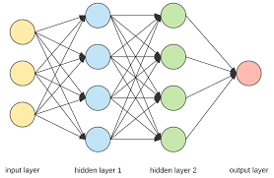

Figure 2: ANN ARCHITECTURE

The above figure is called an ANN Architecture. It is also called an Multi Layer Perceptron (MLP). Its a class of Feedforward Neural Network.The term "multilayer perceptron" does not refer to a single perceptron that has multiple layers.The term "multilayer perceptron" later was applied without respect to nature of the nodes/layers, which can be composed of arbitrarily defined artificial neurons, and not perceptrons specifically. This interpretation avoids the loosening of the definition of "perceptron" to mean an artificial neuron in general.An MLP consists of at least three layers of nodes: an input layer, a hidden layer and an output layer. Except for the input nodes, each node is a neuron that uses a nonlinear activation function. MLP utilizes a supervised learning technique called backpropagation for training.

**4.4. Model Development**

In this study MATLAB is used for development of ANN models.The model parameters are pH, time(min), dose(g/l), concentration(mg/l). A supervised learning technique called Levenberg-Marquardt (LM) is used for the training of the network.The input layer comprises of four (04) number of neurons such as; pH, time (min), dose (g/L) and con- centration (mg/L), while the output layer comprises one (01) neuron i.e.phenol degradation(%). Out Of 29 Runs,70% of the data is used for the training of the network. The remaining data has been divided as 15% for the validation and 15% for the testing of the network.The Collection The Total Number Neurons Present In the unseen row is done by observing the mean square error(MSE).The prediction performance of ANN was evaluated by coefficient of determination (R2), root mean square error (RMSE), mean average deviation(MAD) and absolute average relative error(AARE).

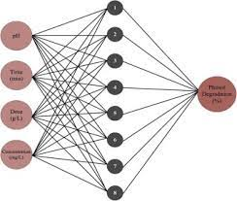

Figure 3: Neural Network Architecture for photodegradation of phenol using TiO2

**5. RESULTS AND DISCUSSIONS**

This chapter deals with the discussion of the results obtained after conducting modelling using Artificial Neural Network (ANN) of the photocatalytic degradation of phenol using Tio2. The results are summarized below as per the data from the modelling by using the methods and materials described above. All of the data in this chapter is a consequence of work done by us to characterize and better understand the feasibility of the project “**Analysis of Photocatalytic degradation using Artificial Neural Network”.**

ANN is a computing method useful to imitate the learning skills of biological cells and the human brain . It has received much interest in the modelling field due to its various characteristics such as reliable, meaningful technique and ability to learn more complex as well as nonlinear processes . In the present study, MATLAB 2018a is used for the development of ANN models. The model parameters as described in Table 1.

|  |  |
| --- | --- |
| Parameters | Values |
| Input Neurons | 04 (pH, time, dose, concentration) |
| Output Neurons | 01 (phenol degradation) |
| Number of Hidden Layers | (1-20)based on minimum MSE |
| Data division function | dividerand |
| Data division | 70% 15% 15% |
| Training function | Levenberg Marquardt (LM) |

Table 2 : Model Parameters

The feed-forward neural network with back propagation method has been used for the model development . A supervised learning technique called Levenberg-Marquardt (LM) was used for the training of the network. The input layer comprises four (04) numbers of neurons such as; pH, time (min), dose (g/L) and concentration (mg/L), while the output layer comprises one (01) neuroni.e. phenol degradation (%) . Out of 29 runs, 70% of the data is used for the training of the network . The remaining data has been divided as 15% for the validation and 15% for the testing of the network. The collection of the total number of neurons present in the unseen row is done by observing the root mean square error (RMSE). The prediction performance of ANN was evaluated by coefficient of determination (R2)

In the entire study, ANN was successfully applied to predict the degradation (%) of phenol. For ANN modelling, the number of neurons in the hidden layer was selected by trial and error to produce the minimum RMSE for the training network. The backpropagation algorithm was used to train the feed forward neural network. The input factors used for feed forward neural networks were: pH of solution, irradiation time, photocatalyst dose and initial phenol concentration while degradation efficiency was used as output variable. Levenberg- Marquardt Algorithm (LMA) was selected because it has the least MSE. To evaluate the optimal number of hidden nodes, a series of architecture was applied. In the current work, the model was tested and trained from 1 to 20 neurons . It is very clear that the RMSE value that is minimum for the training data set is obtained at neurons equal to 13. Hence the best architecture for the ANN model was found to be [4×13×1].

|  |
| --- |
| RMSE VALUES FOR TRAINING DATA SET CORRESPONDING TO NO. OF NEURONS IN HIDDEN LAYER.   1. 24.7485 2. 7.8873 3. 11.6236 4. 7.4161 5. 1.3055 6. 22.7467 7. 12.2799 8. 1.3538 9. 14.8856 10. 1.5907 11. 1.3538 12. 1.3538 13. 0.7905 (minimum of all.) 14. 11.8594 15. 1.2995 16. 12.7949 17. 7.2487 18. 9.4512 19. 9.6497 20. 3.4255 |

Table 3

The below figure 4 depicts the variation of training and validation set for the model when they were plotted in MATLAB.

The ‘x’ is training data and ‘o’ is validation data.

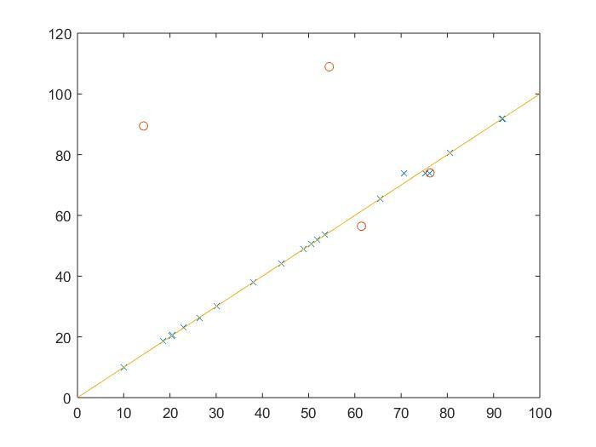 Figure 4: Validation and training data plot

The Predicted Value for 27 observations by ANN model and the Actual Value **(Zulfiqar et al 2019)** that is obtained after doing experiments are listed in this Table 2.

|  |  |
| --- | --- |
| Actual Value / Experimental Values | Predicted Value by ANN model |
| 38 | 37.8349294992484 |
| 51.31 | 42.0861861131118 |
| 65.38 | 65.4030698709763 |
| 48.88 | 48.7567087742938 |
| 70.22 | 74.4634000914352 |
| 23.02 | 23.0832645004387 |
| 51.87 | 51.5359745225007 |
| 18.54 | 18.5388031668472 |
| 91.96 | 91.9399949730770 |
| 61.42 | 79.2088113965446 |
| 30.14 | 30.1909126888799 |
| 91.84 | 97.7491405800254 |
| 70.6 | 74.4634000914352 |
| 99.48 | 99.4783057763233 |
| 75.21 | 74.4634000914352 |
| 20.33 | 20.3734027879866 |
| 20.49 | 16.8434713792379 |
| 80.5 | 80.5912245412593 |
| 53.59 | 53.5937595235679 |
| 48.69 | 48.7885929501796 |
| 26.35 | 22.2813198788912 |
| 76.25 | 74.4634000914352 |
| 76.18 | 74.4634000914352 |
| 54.45 | 54.6295115226115 |
| 50.6 | 52.2712017037299 |
| 44.03 | 44.2007320494173 |
| 14.3 | 14.3433220923241 |

Table 4

The Performance Plot for this model is shown in figure 5 :

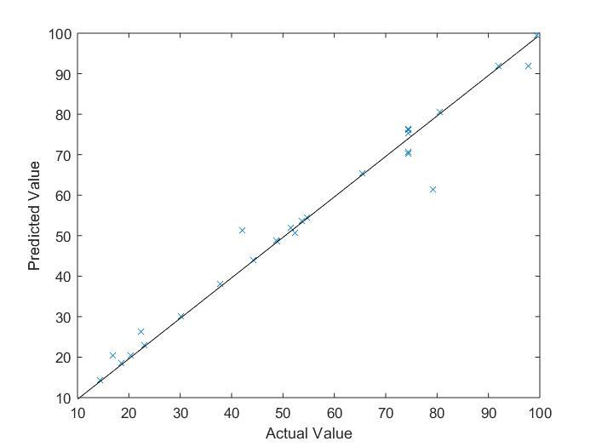

Figure 5 : Performance curve of ANN

The above figure clearly depicts that most of the data fits with the actual values obtained after experiments as they are lying in the close vicinity of y=x line and hence claiming the high accuracy of our model. However this model can be made more accurate if the dataset for training can be of more number of observations.

**6. CONCLUSION & FUTURE WORK**

It can be observed that ANN model is found to be capable of having a higher ability for the prediction of phenol degradation at various operating Parameters. The feed forward neural network with 4 neurons in input layer 13 neurons in hidden layer and 1 neuron in output layer has been trained. The final R value for this model came out to be 0.986 while for the training the value of R was 0.99872 and for the validation purpose the R was found to be 0.97548 and for the testing the value of R was 0.990301. The accuracy can be improved if we use a larger data set for the training of this model.

The iterative approach that was used to get the number of neurons in the hidden layer provides us the optimum number of neurons . if the number of neurons in the layer becomes more than that the system tends to become overfitted and if the number of neurons are less than we have to bear up for the accuracy of the model.

Such type of model can be made for different other pollutants which would definitely help us in predicting the percentage degradation of pollutant in a much more easier and economic way with in very small period of time.

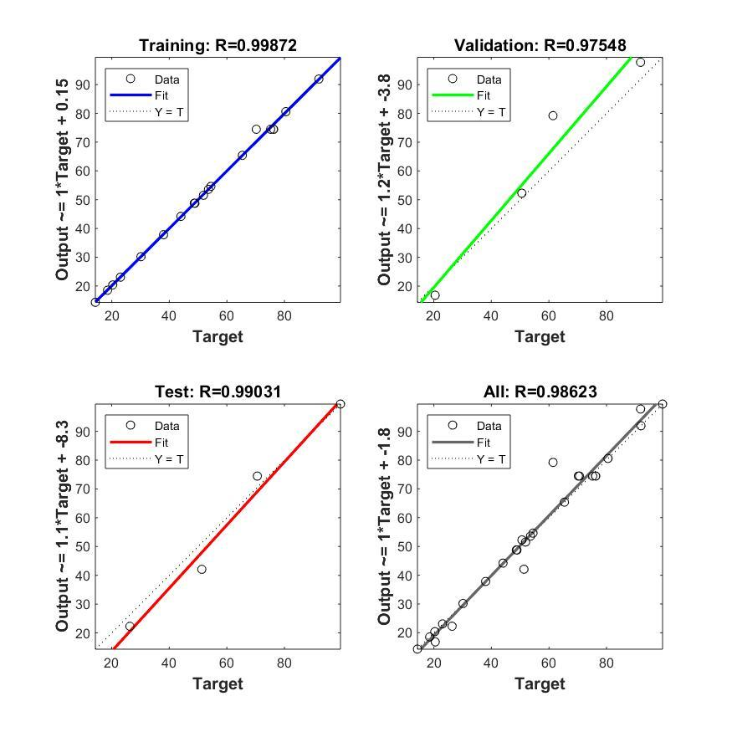

Figure 6 Depicting the values of R obtained in different stages of training.

**7. FUTURE RECOMMENDATION :**

1. ANN is to be used widely in nearly every field of modelling so using it in a precise manner would help us reach results economically and faster .

1. More number of experiments data would help us reach better results as it would be neend during the training phase of the model .
2. Using ANN would save a lot of time to check the degradation experimentally , because using it we can predict the results in a couple of seconds hence research should be promoted on using ANN in degradation techniques .
3. Using other nanoparticles in place of TiO2 for Phenol would help us in knowing the best photocatalysis for a particular pollutant.
4. Research must be made in fabrication of nanoparticles which would make the process even more economical.
5. Research in degradation of air pollutants along with modeling using ANN would give a new way out for chemical industries involving SOx,NOx.
6. Comparative study of technologies such as RSM(response surface Methodology) vs ANN(Artificial Neural Network) should be done which would give a new insight regarding the best fit of ANN.
7. **REFERENCES**

* M.Zulfiqar, M.F.R.Samsudin, S.A.Taqvi, S.Sufian(2019), Modelling and optimization of photocatalytic degradation of phenol via TiO2 nanoparticles: An insight into response surface methodology and artificial neural network, vol. 400, p. 112-649.
* M.Tanzifi, M.T.Yaraki, A.D.Kiadehi, S.H.Hosseini, M.Olazar, A.K. Bhati, S.Agarwal, V.K.Gupta, A.Kazemi(2018), Adsorption of Amido Black 10B from aqueous solution using polyaniline/SiO2 nanocomposite: Experimental investigation and artificial neural network modeling, vol. 510, p. 246-261.
* M.Tanzifi, M.T.Yaraki, M.Karami, S.Karimi, A.D.Kiadehi, K.Karimipour, S.Wang(2018), Modelling of dye adsorption from aqueous solution on polyaniline/carboxymethyl cellulose/TiO2 nanocomposites, vol. 519 , p. 154-173.
* I.Ali , O.M.L.Alharbi , Z.A.Alothmanc, A.Y. Badjah ,A. Alwarthan , A.A.Basheer(2018), Artificial neural network modelling of amido black dye sorption on iron composite nano material: Kinetics and thermodynamics studies, vol. 25, p. 1-8 .
* C. A. Franco, T. Montoya,N. N. Nassar,P.P.Almao, F.B. Cortés(2013), Adsorption and Subsequent Oxidation of Colombian Asphaltenes onto Nickel and/or Palladium Oxide Supported on Fumed Silica Nanoparticles, vol. 80, p. 65-223.
* R.Stiuﬁuc, C.Iacovita,C. M. Lucaciu, G. Stiuﬁuc, R. Nicoara, M. Oltean, V. Chis, E. Bodoki(2013), Adsorption geometry of propranolol enantiomers on silver nanoparticles, vol. 1031, p. 201-206.
* A. saxena, H. Mangal, P.K.Rai, A.S.Rawat, V. Kumar, M.Dutta(2010), Adsorption of diethylclorophosphate on metal oxide nanoparticles under static condition, vol. 180, p. 566-576.
* B. Pergolese, M. Muniz-Miranda, A.Bigotto(2004), Adsorption Models of Bipyrazine on Silver Colloidal Nanoparticles: a Computational Study, vol. 2, p. 000-008.
* M.F.Samsudin, P.J.Jayabalan, W.J. Ong, Y.H.Ng, S.Sufian(2019), Photocatalytic degradation of real industrial poultry wastewater via platinum decorated BiVO4/g-C3N4 photocatalyst under Photobiol. A:Chem., vol. 378, p. 46–56.
* T.T.T. Dang, S. Le, D. Channei, W. Khanitchaidecha, A. Nakaruk(2016), Photodegradation mechanisms of phenol in the photocatalytic process, Res. Chem. Intermed., vol. 42, p. 5961–5974.
* M.F.R. Samsudin, S. Sufian, B.H. Hameed(2018), Epigrammatic progress and perspective on the photocatalytic properties of BiVO4-based photocatalyst in photocatalytic water treatment technology:a review, J.Mol.Liq., vol. 268, p. 438–459.
* M.Hadnadjev-Kostic, T.Vulic, R.Marinkovic-Neducin, D.Lončarević, J.Dostanić, S. Markov, et al.(2017), Photo-induced properties of photocatalysts: a study on the mod- ified structural, optical and textural properties of TiO2–ZnAl layered double hy- droxide based materials, J. Clean. Prod., vol. 164, p. 1–18.
* Wu Y, Wadia C, Ma W(2008), “Synthesis and photovoltaic application of copper (I) sulﬁde nanocrystals”-Nano Lett, vol. 8, p. 25512555.
* Xu H, Wang W, Zhu W(2006), “Sonochemical synthesis of crystalline CuS nanoplates via an in situ template route”-Mater Lett, vol. 60, p. 22032206.
* Pei LZ, Wang JF, Tao XX(2011), “Synthesis of CuS and Cu1.1Fe1.1S2 crystals and their electrochemical properties”-Mater Characterization, vol. 62, p. 354359.
* Wu C. Facile(2014), “one-step synthesis of N-doped ZnO micro polyhedrons for efficient photocatalytic degradation of formaldehyde under visible-light irradiation” Appl Surf Sci, vol. 319, p.237–43.
* Gu P, Wang X, Li T, H Meng(2013), “Investigation of defects in N-doped ZnO powders prepared by a facile solvothermal method and their UV photocatalytic properties”-Mater Res Bull, vol. 48, p. 4699–703.
* N.Al-Hayek, M.Dore(1990), Oxidation of phenols in water by hydrogen peroxide on alumine supported iron, Water Research, vol. 24, p. 973-982.
* R.Andreozzi, V.Caprio, A.Insola., R.Marotta(1999), Advanced oxidation process (AOP) for water purification and recovery, Catal. Today, vol. 53, p. 51-59.
* N.Azbar, K.K.Yonar., (2004), Comparison of various advanced oxidation processes and chemical treatment methods for COD and color removal from a polyester and acetate fiber dyeing effluent, Chemosphere, vol. 55, p. 35-43.